After this series of courses，From week1's obscurity to Week7's proficiency. In each session, we will learn about the different functions and uses of Github. There are also a lot of difficulties encountered, but the teacher can always be patient and careful guidance we change how to operate. The problems raised before have almost been solved. However, when we browse the Internet, we always appear "sorry, your network is lost", which makes us very upset. We can't take classes or finish our homework well. On the whole, we got a lot.

The teacher demonstrates the operation process very carefully and always answers our questions in time. Although, some still do not understand, but with the help of classmates can be completed.

We made a series of web pages with GitHub and Gitbash. The process was a little difficult, but with the teacher's patient guidance and unremitting efforts, we finally made it. I am really happy and grateful to the teacher.

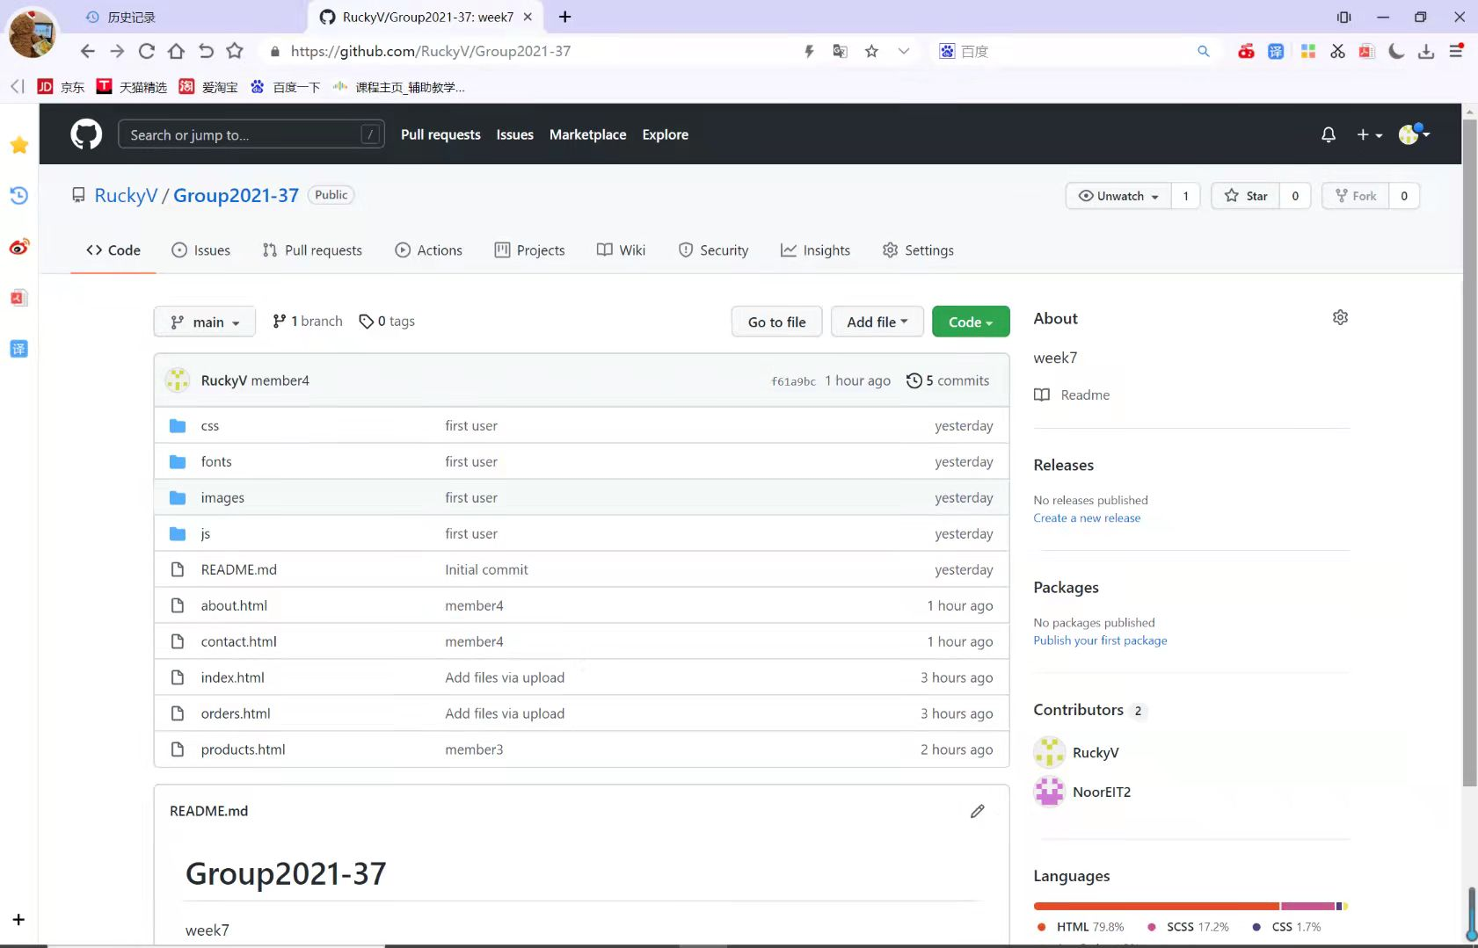

HOME

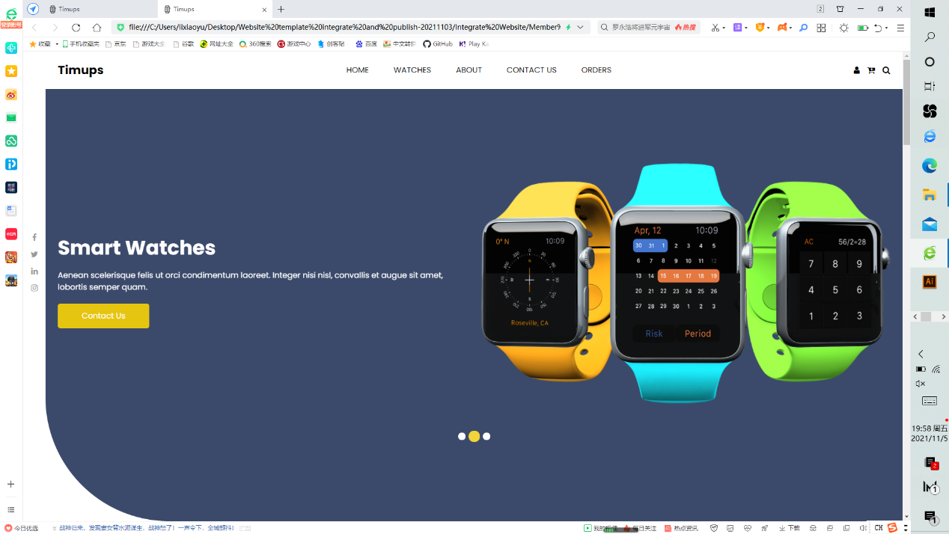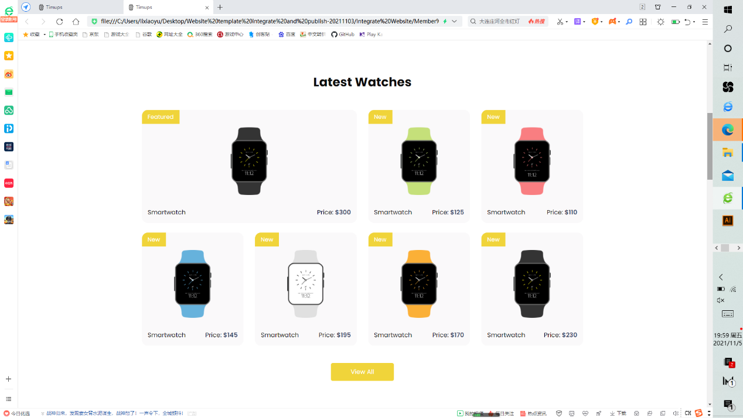

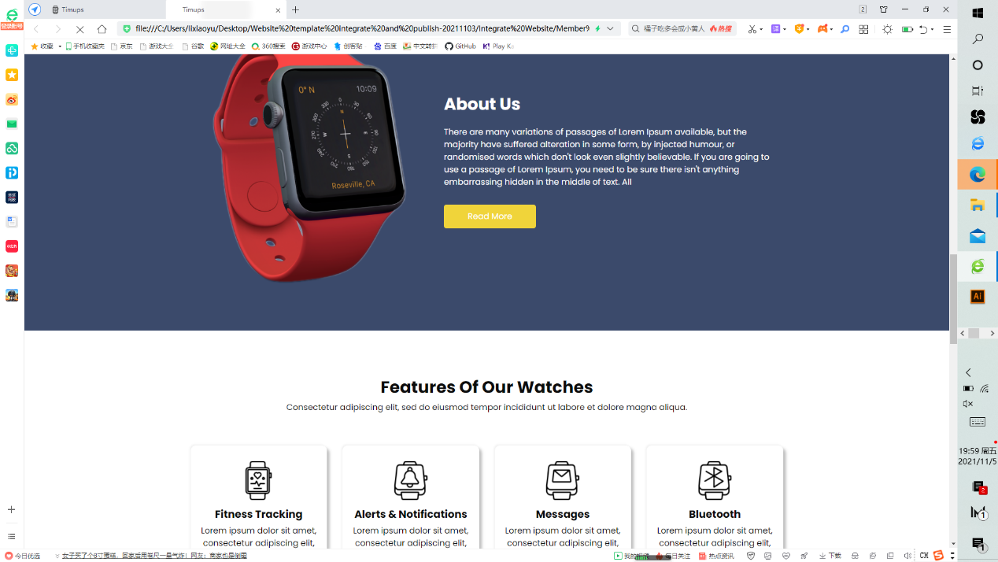

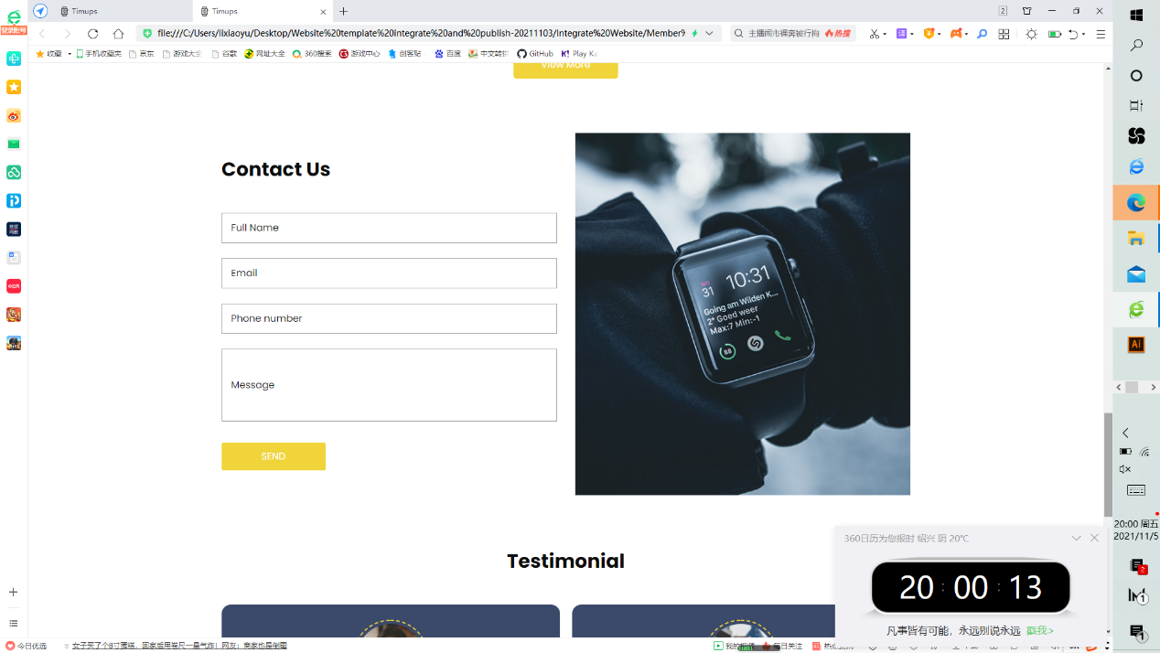

PRODUCTS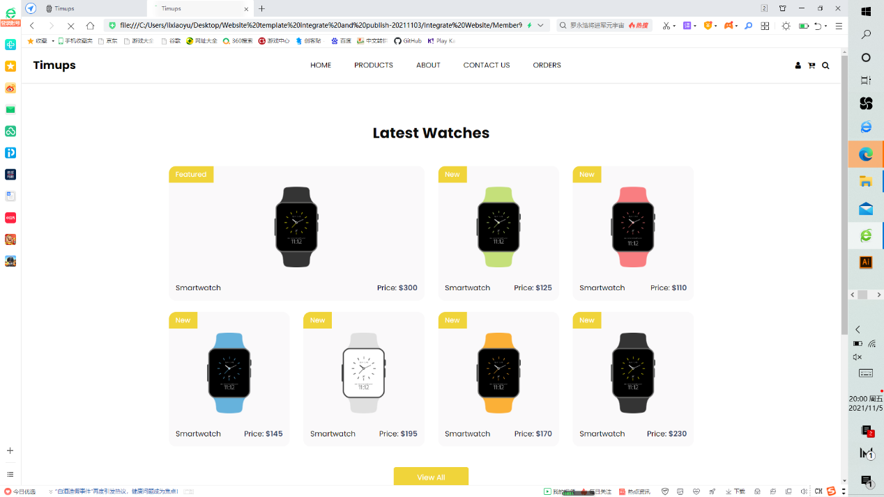

ABOUT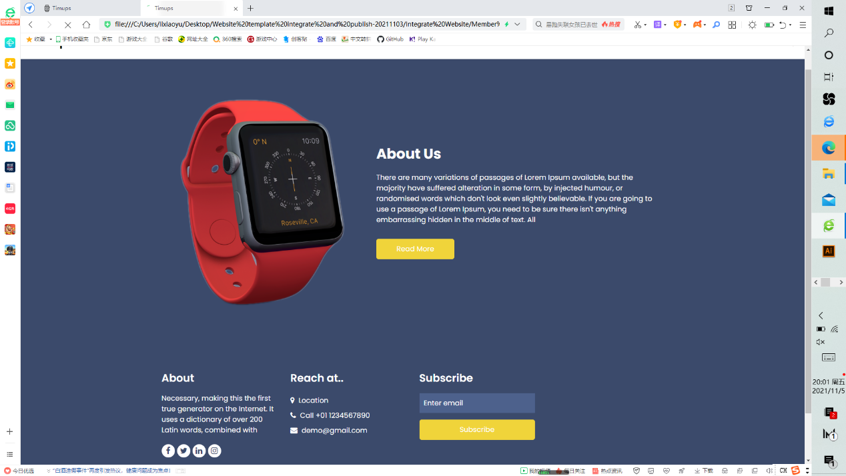

CONTACT US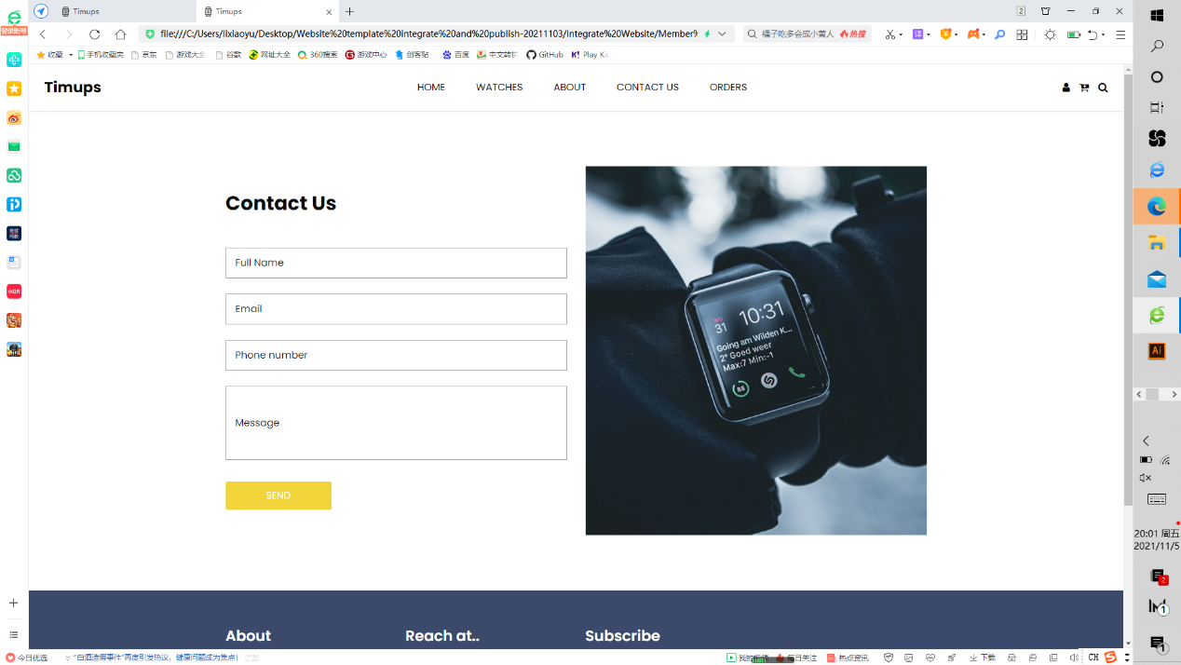

ORDERS